Becky Matthews-Pease

Cesar Renato Cruzalegui

Charles Knight

John Leo Bartlett

**1. What were the time frames for each marketing campaign? How much was spent on each campaign? What was the effectiveness of previous campaigns? (40%)**

The above table shows the data on each campaign, pulled directly from google analytics.

1. **whitman.syr.edu**

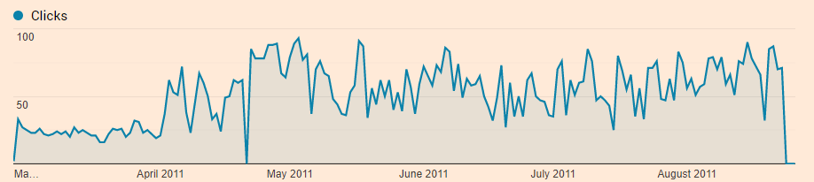

1. **MBA Marketing – Full-time**

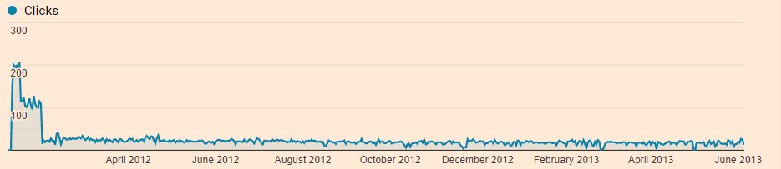

1. **MBA Marketing – iMBA**

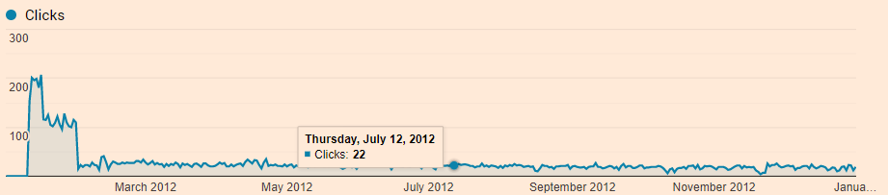

**d. Delta**

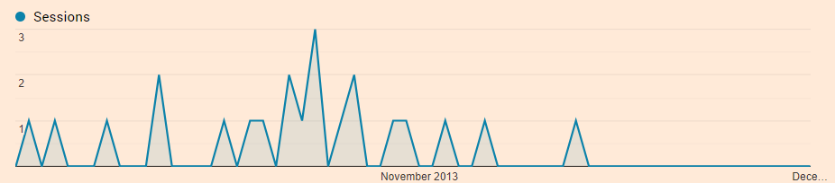

The most effective ad campaign in terms of cost, CPC, sessions, bounce rate is the Whitman.syr.edu ad campaign, while having the lowest total cost and CPC by far it had a similarly high number of clicks and the lowest bounce rate of all of the other campaigns.

**Predicting the future average CPC based off the CPC for the 3 previous ad campaigns and the year in which they took place.**

We performed a regression analysis on the CPC and the year of the campaign:

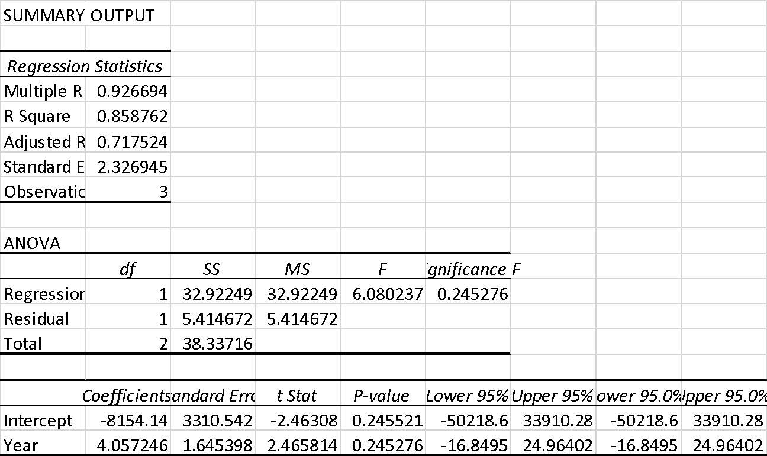

This equates to an average increase in CPC of about 4.06 dollars a year.

Couple this regression with a prediction table:

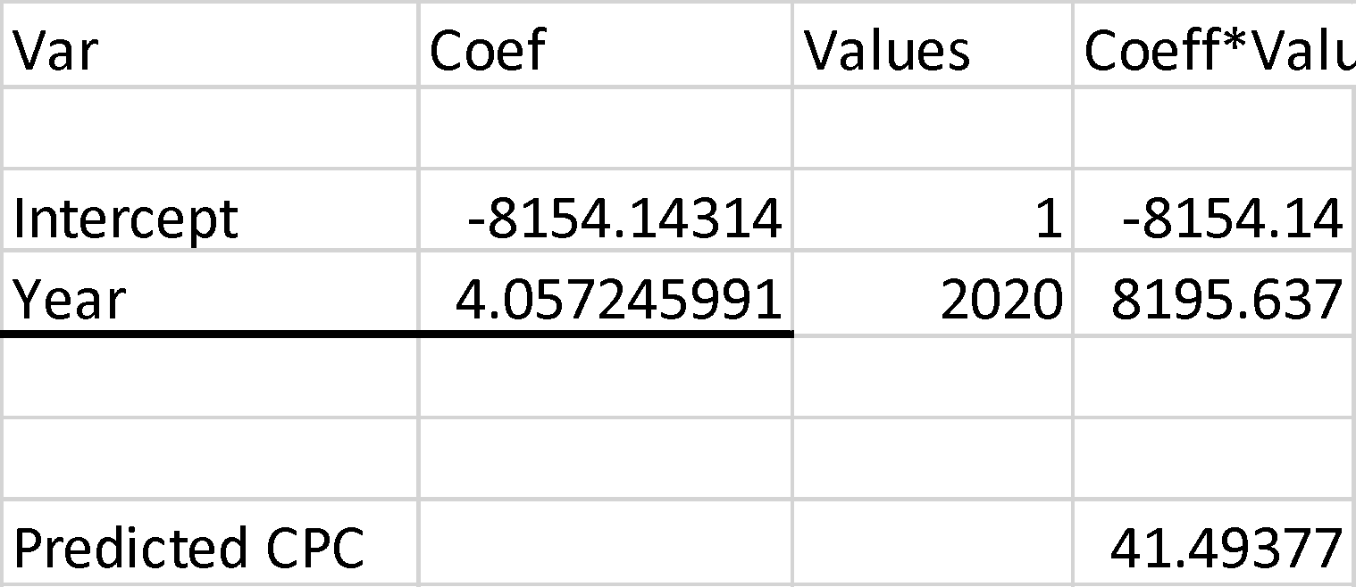

We surmise that the Cost Per Click in the year 2020 will be somewhere around $41.50 based off of the data extracted from the 4 campaigns.

Below is a table illustrating the changing CPC from the years 2010 to 2022 according to the regression prediction model:



The caveat to this prediction is that it produces an extremely strict linear growth for the CPC. This is most likely due to the regression only using a small amount of data to predict the CPC, so this may be inflated, $41.50 does seem awfully expensive, albeit there is a large gap of data from the latest campaign 2012 to current day.

We predicted a similar result when using a forecasting method, each prediction was very linear.

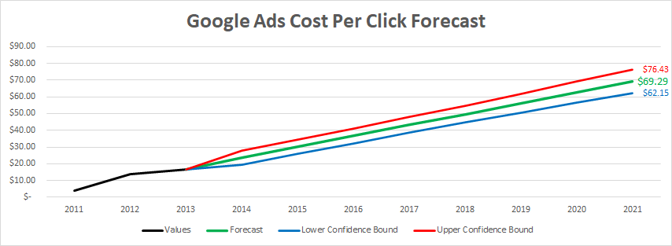

**2. Identify the key aspects of a United States campaign for next year (20%) a. In which geographic region would you advertise? Which states? Why?**

**Advertising regions**

Using the Whit MBA campaign as a template for future campaign investments we identified the top 10 states with the highest count of new users. Below is a list of the 10 states with the highest count of new users (synonymous with new sessions).

|  |  |  |
| --- | --- | --- |
| **1.** | **New York** | **160,795** |
| **2.** | **California** | **32,338** |
| **3.** | **Texas** | **20,994** |
| **4.** | **New Jersey** | **17,574** |
| **5.** | **Massachusetts** | **17,572** |
| **6.** | **Florida** | **17,459** |
| **7.** | **Virginia** | **16,608** |
| **8.** | **Pennsylvania** | **15,951** |
| **9.** | **North Carolina** | **11,964** |
| **10.** | **Illinois** | **11,951** |

The count of new users is arguably the most important metric as it is essentially a measure of how many new people were exposed to the Whitman.syr.edu website and the various campaigns. Developing a weighted approach to targeting these top 10 states is the best course of action, it is our hypothesis that the states with the highest volume of new users will produce the greatest volume of new users when undergoing a new campaign.

The geographic focus of the campaign would be the east coast/New England area stretching from Ohio up through New York and Massachusetts, and along the east coast along down to Florida. The states of California, Illinois, and Texas would also be included in the geographic focus area. These states have consistently been where most of the traffic has come from within the US during the 2011-2013 campaigns. The New English/East coast area is to be expected due to proximity, and California, Illinois, and Texas likely due to their high overall populations. In addition to being the states from which the most of the traffic for the campaigns came, these states also trended to having higher average page views and session durations while also having lower bounce rates.

**b. What keywords would you use? Why?**

Below is a table of the keywords from previous campaigns, based on this data we chose to select a subset of this table, those highlighted are our selections. The first two (online MBA and MBA) reflect the most effective keywords, generating the most clicks, albeit while being the most expensive in terms of CPC. The remaining 5 keywords are similarly the next 5 most effective keywords, but they come with the added benefit of being less than half the CPC of the first top 2 keywords, making them great candidates for future campaigns in terms of cost effectiveness. The latter reflect keywords that had an agreeable CPC of under 6 while generating a fraction of clicks compared to those with top clicks. These last picks are acceptable mainly due to their affordability.

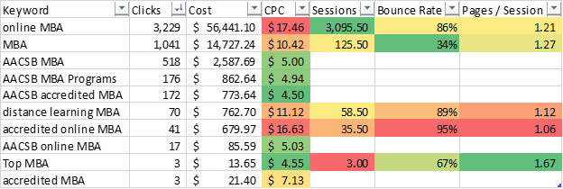

For each of the campaigns, keywords and search terms most frequently included “MBA” and “online.” For the years 2012 and 2013, and “AACSB” combined with “MBA” and “online” to form the top 4 most commonly used words in search phrases. “Syracuse” was also among the most commonly used phrases for two of those three campaigns. The forecasted Cost per Click for the term “MBA” falls in the middle of these five terms in terms of highest cost, but is forecasted to gain the most clicks; as such, this would be of higher focus than other terms. Terms related to accreditation are forecasted to have fewer clicks, but at the highest cost, so while this should be included in the campaign, focus would be lower than “online” which forecasts higher numbers of clicks at a lower cost. “Syracuse” would also be an important keyword to include, but since it will be in lower demand among competing websites, we would be able to focus more of the budget on those more generalized terms.

**c. Which days of the week and what time of day would you advertise? Why?**

Mondays, Wednesdays, and Sundays would be the primary days of focus for the campaign. Over the last three campaigns, these three days have consistently remained among the top three days in terms of the number of users, sessions, pages per session, and average duration of session. Thursdays and Thursdays have historically been the days of the week with the least activity, so fewer resources should go into advertising on those days.

**Time chart of sessions by day of the week:**

(0 is Monday)

Whitman.syr.edu (exclude SU)

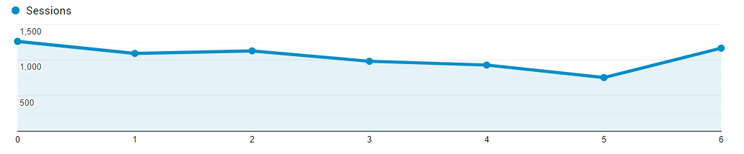

MBA Marketing – Full-Time

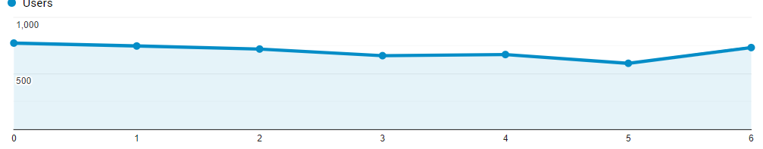

MBA Marketing – iMBA

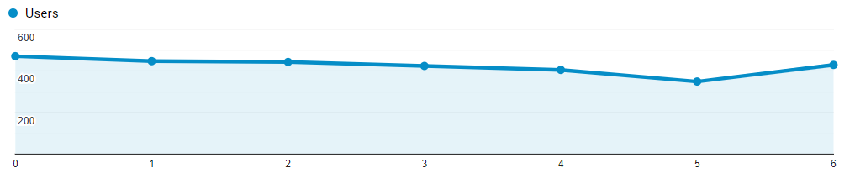

**Take away:**

Saturdays (5) generate a noticeably lower amount of activity than the other 6 days of the week, for this reason we believe it will be more effective to ignore this day and focus any advertising budget on the other 6 days of the week.

The highest number of users/sessions has, in the past three campaigns, occurred between 5:00 PM and 11:59 PM, with the hours of 8:00 PM – 10:00 PM consistently being the highest among these peak hours. These hours contain bounce rates, pages per session, and length of session near their respective overall averages.

While the hours of 3:00 AM – 8:00 AM have fewer users/sessions, the pages per session and average duration of sessions are both higher than average. This suggests that while perhaps fewer individuals are spending time on the website during these hours, those users are spending more time and browsing more thoroughly.

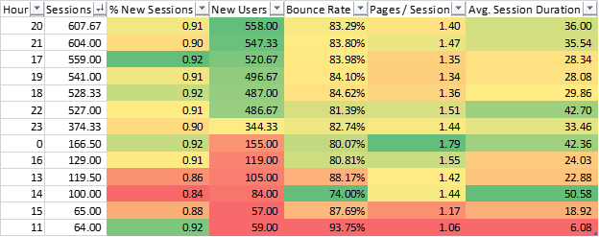

**Time chart of sessions by hour of the day:**

Whitman.syr.edu (Exclude – SU)

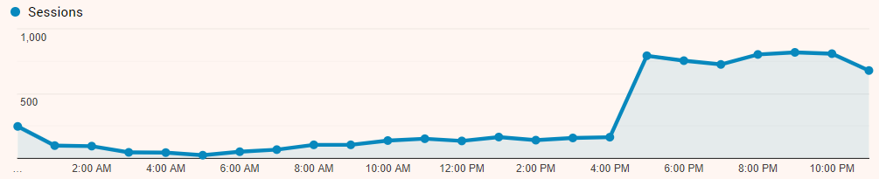

MBA Marketing – Full-Time

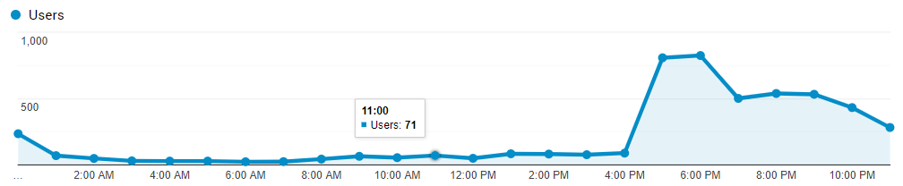

MBA Marketing – iMBA

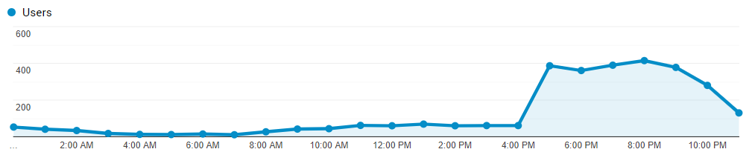

**Take away:**

It’s clear that the vast bulk of sessions occur in the after work hours of the day. This will be the targeted campaign activation time, starting at 4:00PM and ending after midnight 1:00am.

**3. Identify the costs for your advertising campaigns (10%)**

**a. By region**

The breakdown of the budget according to region should primarily reflect the most highly trafficked region. All while proportionately being allocation to the latter 9 regions of the top 10 regions.

It’s important to note that the left over 40 states and DC represent 24% percent of the total clicks, still a sizeable portion but being that each state in this group represents less than 2% of total clicks there isn’t much value in balancing the budget in proportion to that states total click, for this reason we will group them into a ‘leftover’ group and they should receive the remainder of the budget separated equally.

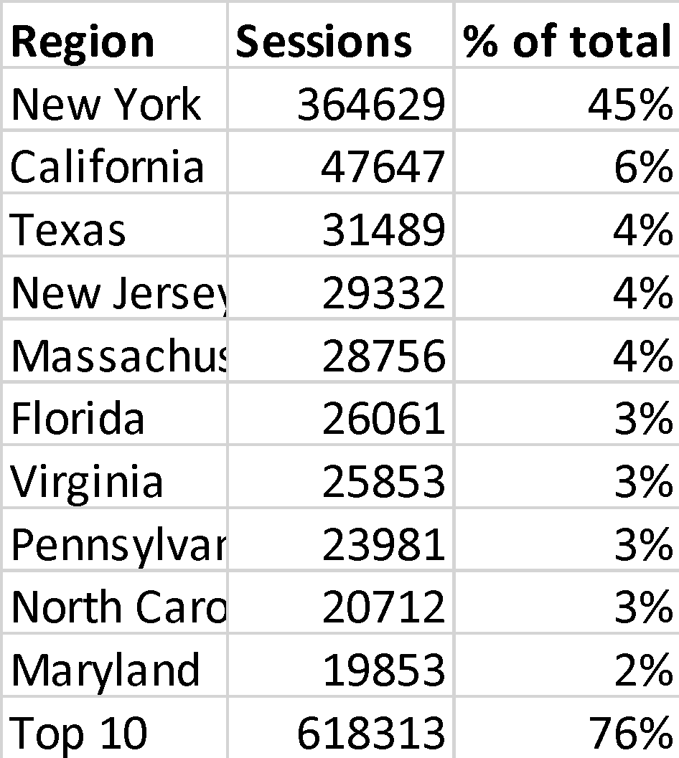

**b. By degree program**

The breakdown of the budget according to degree program (MBA Full-time vs iMBA) should be balanced according to the percentage of total click that each of the previous MBA campaigns received:

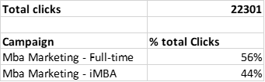

This will ensure that both campaigns get funds according to the effectiveness of their predecessors. When combining our two budgeting perspectives we get something like this:

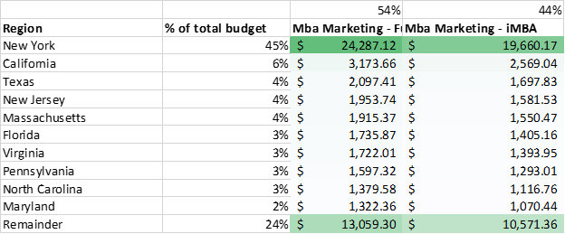

This completely breaks out the budget into equally weighted chunks based on the past successfulness of the 2 previous MBA campaigns and the top ten most effective states with the remaining states receiving an evenly split share.

By factoring in the average CPC that we calculated earlier we can get a more precise budget adjusted to account for the exact cost of clicks:

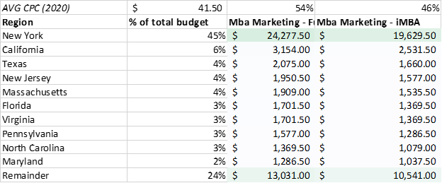

This time with some left of capital to spend while the campaign is underway (targeted in an agile method)



This more precise budget gives us an accurate picture of how many clicks each subsection will be able to pay for. This could allow us to forecast how many clicks we will potentially receive.

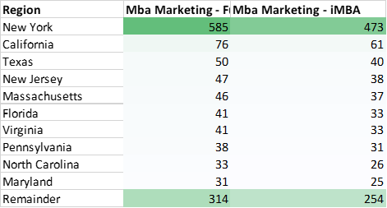

This number of clicks is starkly lower than those in the previous campaigns, if our predicted CPC is accurate then the budget will surely need to be raised to get similar results as the previous 2 campaigns.

**4. How would you measure performance of your decisions after implementation? (20%)**

Performance can be measured in terms of the amount of clicks, sessions, and new users that each of these campaigns generate, comparing this new campaign data to that of the old campaigns will give a solid frame of reference in terms of the effectiveness of the campaign.

It would also be interesting to develop a way to correlate this Google Analytics data with that of the enrollment data for the actual programs we are advertising, we would assume that a strong correlation between our campaign regions, demographics etc. and that of enrollment data would suggest that our campaign is effective.

Another way could be to survey matriculated students to figure out what percentage of them were exposed to SU MBA programs by our campaign.

In addition, in order to measure success of the campaign I would like to understand if while visiting the program website the visitor submitted an application to the program which would be one of the main goals of the campaign.

**5. What other factors or considerations are important? What other data would help in developing an Internet advertising strategy if you could collect it? (10%)**

Adding additional demographic data about the visitor will be important to analyze when coming up with campaigns. With the data set currently available it is hard to determine the likes of the visitor, perhaps ability to track visitors behavior that will drive future campaign dollars. Age, Gender, and other individual factors about the website users could provide helpful insight. The campaign can expand beyond the ad words to banners, youtube video ads and print media campaigns similar to the delta campaign that was used.

If we want to focus our campaign on prospective students with high GMAT scores then some data on regional GMAT scores could provide insight on what regions would be effective to target to secure more highly scoring students. Surveying the existing student body about what aspects of the Management MBA attracted them to SU could be valuable to apply to our thought process when choosing search terms.